📄 Project Documentation: Hospital Management System

## 📌 Objective

To create a simple Java-based Hospital management system that allows adding patients, viewing patients, viewing doctor, book Appointment .

## 🛠️ Technologies Used

- Language: Java  
- IDE: Eclipse  
- Database: MySQL   
- JDBC: For database connectivity  
- Version Control: Git and GitHUB

## 📂 Project Structure

JDBCDEMO/  
├── src /  
│ ├── Patient.java  
│ ├── Doctor.java   
│ └── Main.java  
├── README.md  
└── Documentation/  
 └── ProjectDocumentation.docx

## 🔍 Modules/Features

1. Add Patients  
2. View Patients  
3. View Doctors   
4. Book Appointment

## 👤 User Roles

- Admin (add patients/view patients/add doctors)  
- Member (book Appointment — limited actions)

## 📋 Class Design

1. Patient Class  
   - Attributes: id, name, age, gender  
   - Methods: addPatient(), viewPatients(), getPatientByID()

2. Doctor Class  
- Attributes: Id, name, specilization  
- Methods: viewDoctors(), getDoctorByID()  
  
3. Main Class  
- Attributes: Patient ID, Doctor ID,Appointment date  
- Methods: bookAppointment(), checkDoctorAvailability()

## 🧪 Sample Test Cases

|  |  |  |
| --- | --- | --- |
| Feature | Input | Expected Output |
| Add Patients | Enter name: sai, age:22, gender: male | Patient added successfully |
| View Patients | - | List of Patients |
| View Doctors | - | List of Doctors |
| Book Appointment | Doctor ID: 101, Patient ID: 1 Appointment date:2025-11-13 | Book Appointment successfully |

## 🧾 How to Run

## 1. create a “hospital” database with relevant tables.

## 2. Update database credentials in “HospitalManagementSystem.java”.

## 3. Open project in your IDE(Eclipse).

## 4. Compile and run “HospitalManagementSystem.java”.

## 5. Use the console menu to operate the system.

## 🔐 Future Enhancements

- Integration with MySQL database  
- User authentication system  
- Book Appointment feature  
- Report generation

## 📌 Author

- Name: KUNDEM PRANAV VENKAT  
- Contact: [pranavvenkat2005@gmail.com](mailto:pranavvenkat2005@gmail.com)

-GitHub: https: <https://github.com/pranav1-rock/Hospital-Management-System>

🖼️ System Architecture Diagram

Below is a simple architecture diagram showing how different components interact:

[User Interface]  
 ↓  
[Hospital.java]  
 ↓  
[Patient.java] ↔ [Doctor.java]  
 ↓  
[Database (MySQL)]

## 📸 Sample Screenshots

Screenshots showing the menu-driven interface in console output:

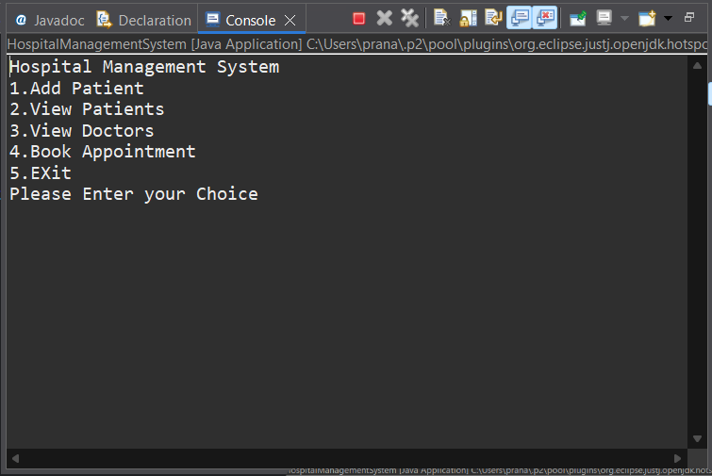  
========= Hospital Management System =========  
1. Add Patients  
2. View Patients  
3. View Doctors  
4. Book Appointment  
5. Exit  
 Please Enter your choice:

The system takes user input and performs operations based on the selected menu item.